INFOSYS SPRINGBOARD VIRTUAL INTERNSHIP
MODULE 4

Name: Shiven Pratap Singh

Project Name: HotelRevAI AI Driven Revenue Analysis for Hotels_Batch -13

Module 4 is centered on examining booking reliability by studying cancellations, no-shows, refund trends, and predicting future demand. In this stage, several analytical fields were introduced, including Cancellation Flag, Cancellation Rate, Lead Time, Refund Amount, and No-Show indicators.
These attributes help identify patterns in unreliable bookings and provide a better understanding of customer behavior, allowing for more accurate forecasting and improved decision-making.
By leveraging Power BI, DAX, and its built-in forecasting capabilities, this module enables hotels to predict future occupancy levels, assess the risk of cancellations, and make more informed decisions related to pricing and operations.
This layer of analysis enhances revenue planning by highlighting key trends and patterns that influence business performance, helping management take proactive steps to improve efficiency and profitability.

Creating CancellationFlag (Identifying Cancelled Bookings):

To clearly distinguish between cancelled bookings and successfully completed stays, a new analytical field named Cancellation Flag was introduced. This column helps in easily identifying and separating cancelled records for more accurate analysis.
This column classifies each booking as “Yes” (Cancelled) or “No” (Not Cancelled).

DAX Formula Used:
CancellationFlag = IF(Booking[BookingStatus] = "Cancelled", "Yes", "No")

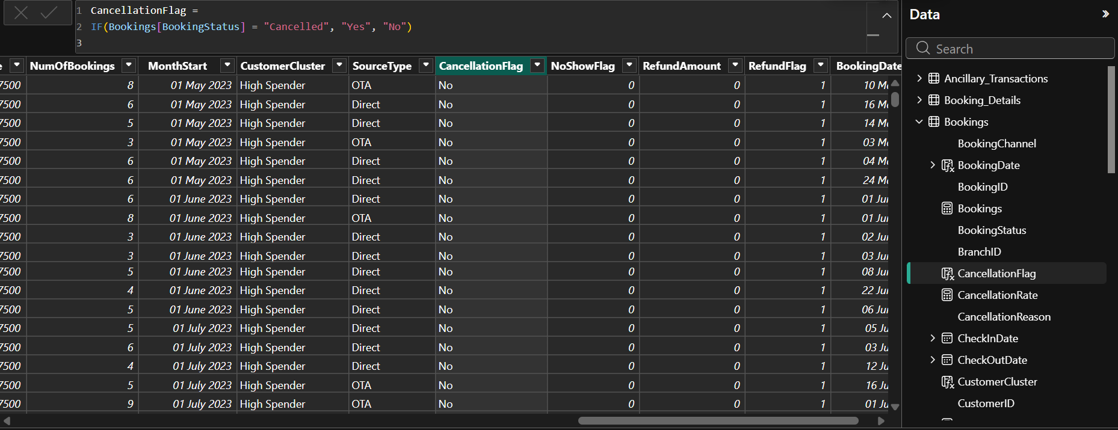

LeadTime (Understanding Booking Behavior)-

Lead Time represents the number of days between when a booking is made and the actual check-in date. It is an important factor in predicting cancellations, as reservations made either too far in advance or at the last minute are often more likely to be cancelled.

RefundAmount (Financial Impact of Cancellations):

Refund Amount represents the money returned to customers when a booking is cancelled. This metric is useful for evaluating the financial impact of cancellations and understanding potential revenue loss.

DAX Formula Used:
RefundAmount = IF(
Booking[BookingStatus] = "Cancelled", Booking[Revenue],
0
)

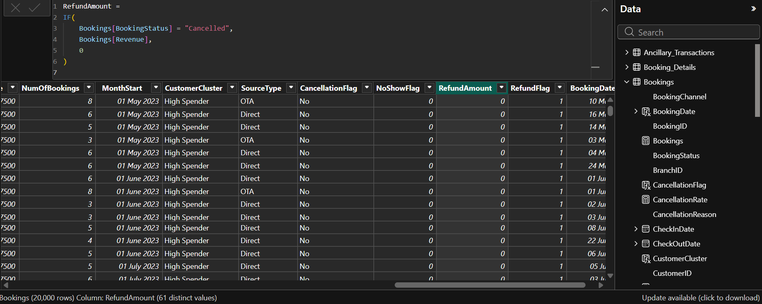

RefundFlag:

Refund Flag indicates whether a particular booking led to a refund or not. This helps categorize cancellations based on their financial impact, making it easier to analyze revenue-related outcomes.

DAX Formula Used:
RefundFlag =
IF(NOT(ISBLANK(Booking[RefundAmount])), 1, 0)

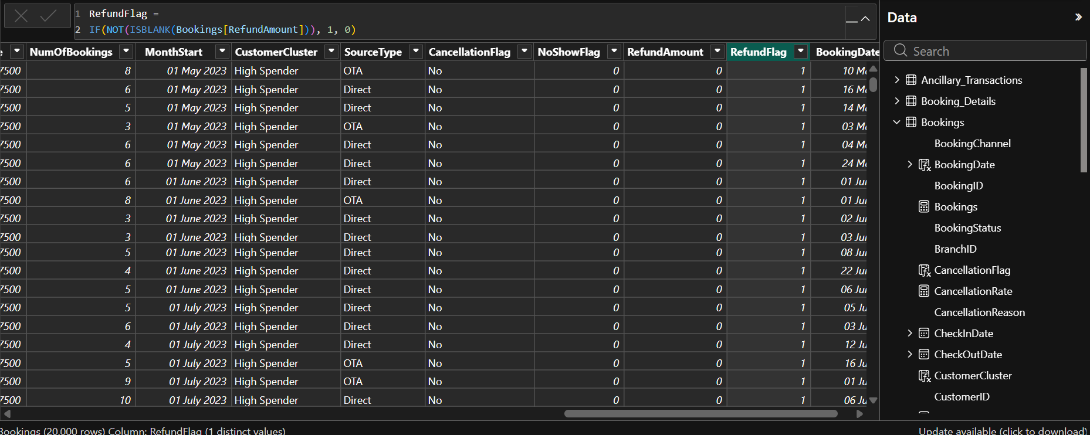

NoShowFlag (Identifying No-Show Guests):

No-shows negatively impact both hotel revenue and operational efficiency. To address this, a NoShow Flag column was introduced to identify guests who failed to arrive despite having a confirmed booking.

DAX Formula Used:
NoShowFlag =
IF(Booking[BookingStatus] = "No-Show", 1, 0)

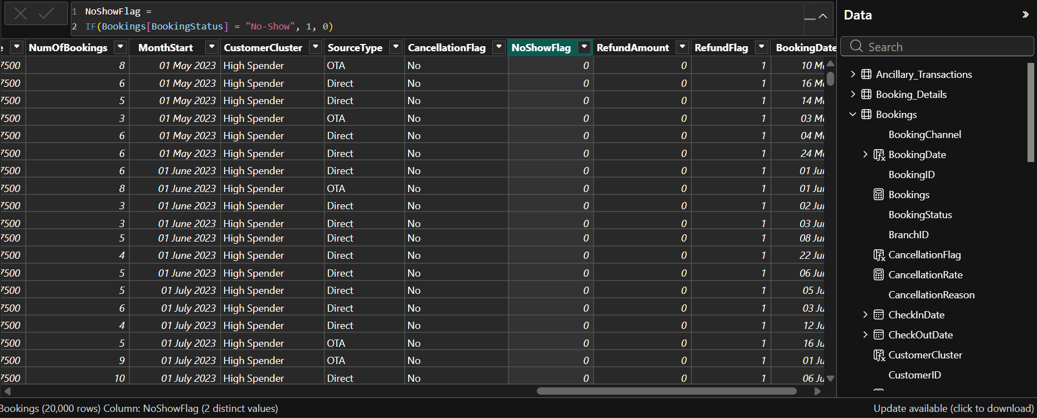

RoomRate and DADR-
RoomRate is pulled from the RoomType table and represents the base price of each room category.

DAX Formula Used: RoomRate = RELATED(RoomType[Price])
DADR (Derived ADR) calculates the average daily rate based on available room pricing.

DAX Formula Used:
DADR = AVERAGE(Booking[RoomRate])

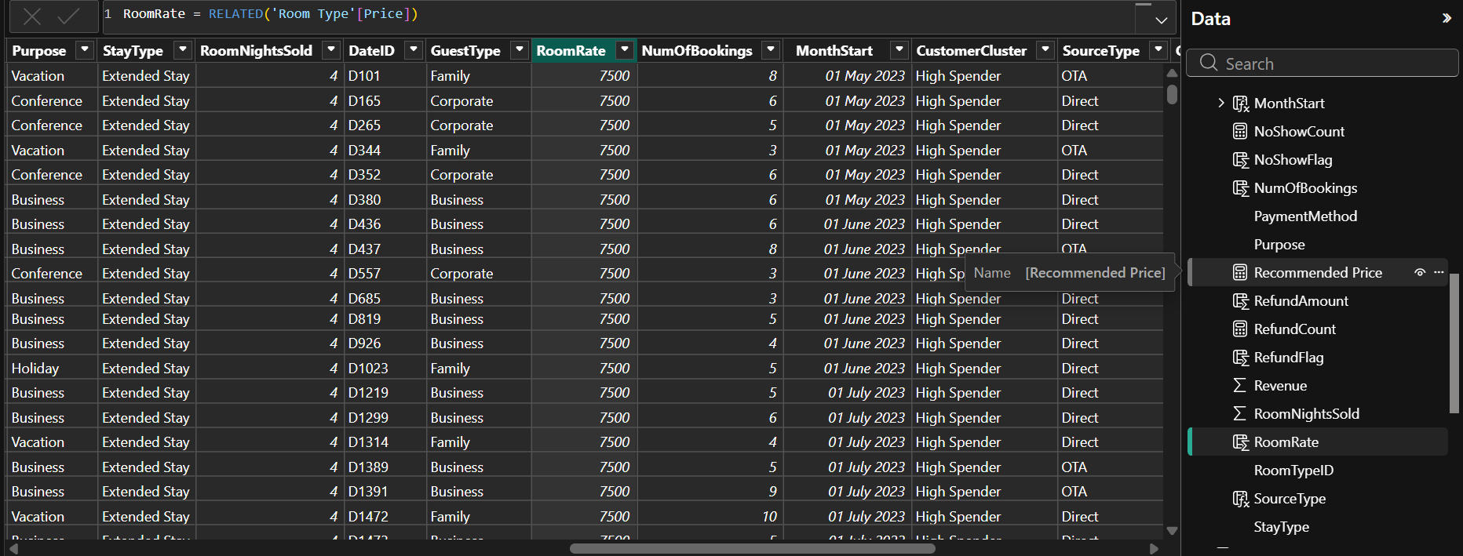

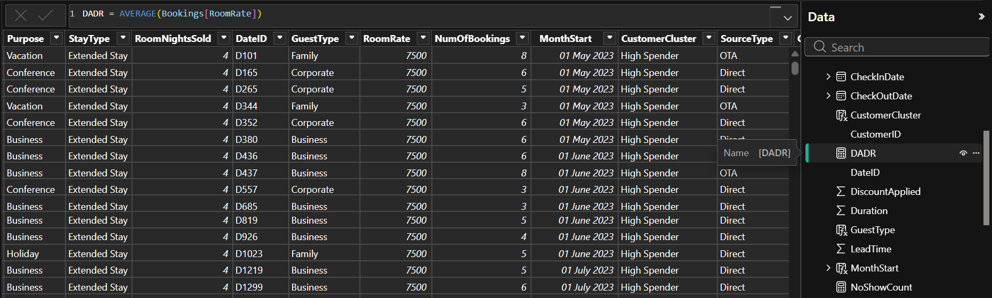

These metrics are important for forecasting revenue and supporting price optimization analytics.

Recommended Price (Dynamic Price Forecasting Output)-
A pricing model was created using variables such as seasonality adjustment, price uplift, and occupancy elasticity.
The Recommended Price column calculates an optimized room price for future demand forecasting.

DAX Formula Used:

Recommended Price = VAR BaseADR = [DADR]
VAR SeasonAdj = [Season Adj]
VAR Uplift = [Price Uplift % Value]
VAR Elasticity = [Occupancy Sensitivity Value] RETURN
BaseADR * (1 + SeasonAdj + Uplift) * Elasticity

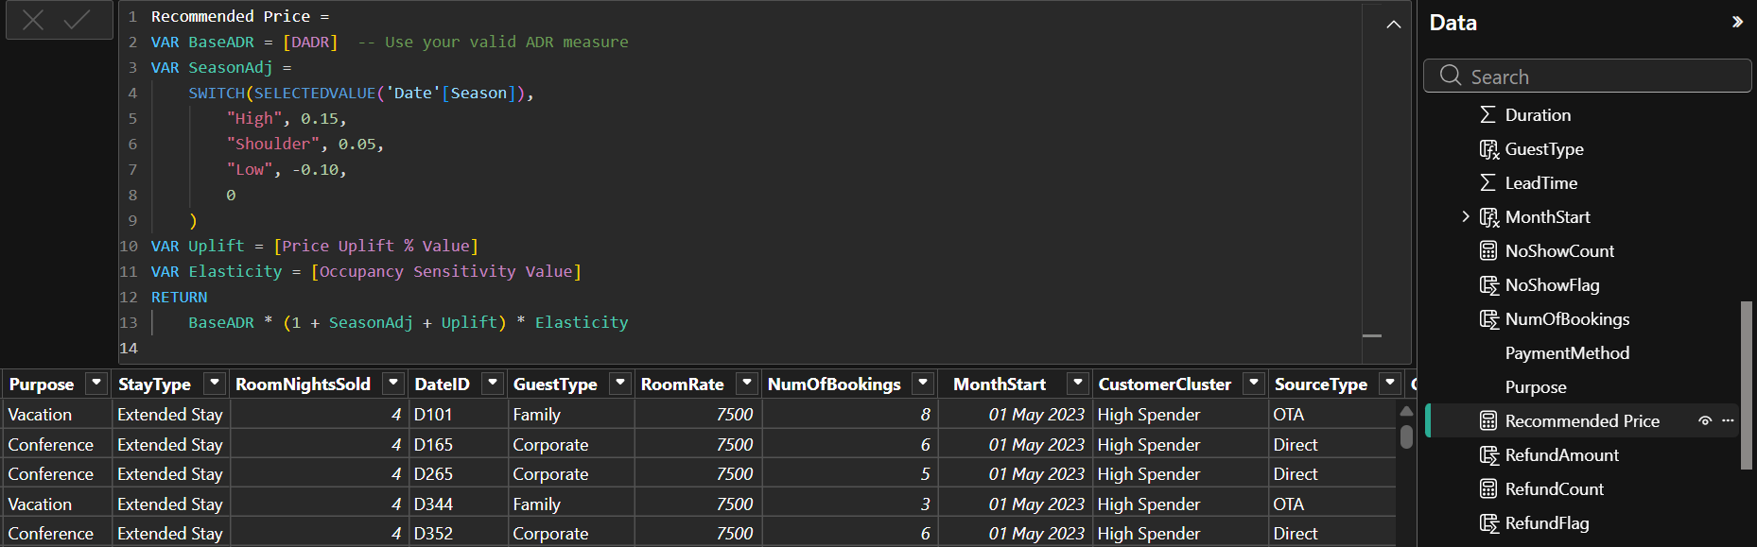
This helps simulate how price changes influence future occupancy and supports revenue management decisions.

MEASURES-

CancellationRate (Percentage of Cancelled Bookings):
CancellationRate is the key performance indicator for understanding booking reliability. This measure calculates the ratio of cancelled bookings to total bookings.
DAX Formula Used:
CancellationRate =
DIVIDE(
COUNTROWS(FILTER(
Booking,
Booking[CancellationFlag] = "Yes"
)
),
COUNTROWS(Booking)
)

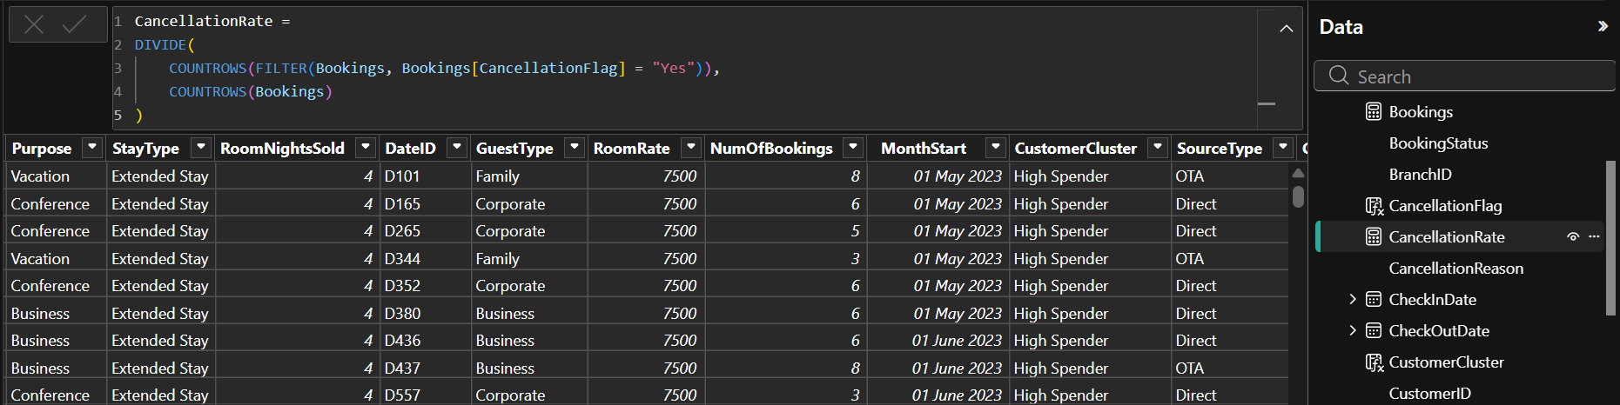
This gives insights into how often guests cancel and helps compare cancellation patterns across segments like booking channel, room type, or guest type.

NoShowCount (Measure to Count No-Shows):
A measure was created to calculate the total number of no-show bookings.

DAX Formula Used:
NoShowCount =
CALCULATE(
COUNTROWS(Booking),
Booking[BookingStatus] = "No-Show"
)
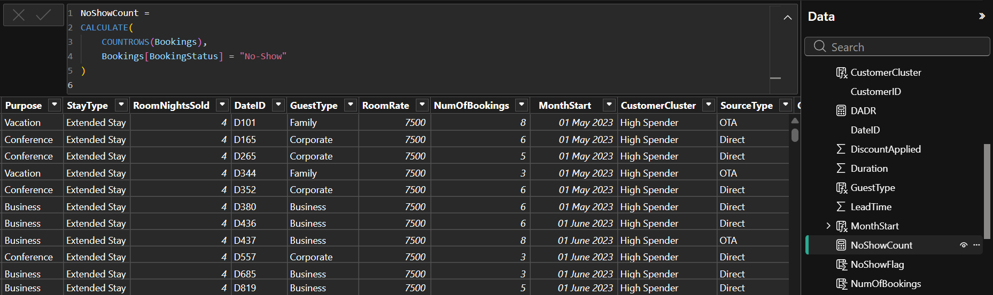

This helps visualize no-show patterns by time period, booking channel, gender, or other segmentation fields.

Visualization and Analysis: (Output)
After creating analytical fields such as CancellationFlag, CancellationRate, LeadTime, NoShowFlag, RefundAmount, and forecasting metrics, several Power BI visualizations were developed to understand cancellation behavior, no-show patterns, refund impact, and future occupancy predictions.
These visuals help interpret operational risks, identify seasonal patterns, and provide data- driven insights for planning future demand.

Future Occupancy Forecast
A line chart was created to forecast future occupancy by applying Power BI’s built-in forecasting model on historical occupancy trends. The visual displays both actual historical occupancy and predicted future occupancy, along with a shaded confidence band showing the uncertainty range.
To generate the forecast, the following configuration was applied inside Power BI:
  - Units: Months
  - Forecast Length: 7 Months
  - Ignore Last: 0 data points
  - Seasonality: Auto- detected
  - Confidence Interval: 95%

These settings allow Power BI to automatically detect repeating seasonal patterns and extend future occupancy values based on exponential smoothing.
The confidence interval (shaded grey area) highlights upper and lower bounds of expected occupancy.
This visualization helps hotels:
  - anticipate upcoming high-demand months,
  - plan staffing and room inventory,
  - create proactive pricing strategies, and
  - prepare for occupancy fluctuations.

Cancellation Rate Over Time
A line chart highlights the monthly and yearly cancellation rate using the CancellationRate
measure.
This visualization shows how cancellations vary across seasons, allowing the hotel to identify patterns such as:

  - months with peak cancellations,
  - booking periods with unstable customer behavior, and
  - seasonal cancellation spikes that may require policy adjustments.
Understanding cancellation volatility supports strategic planning and improves forecasting accuracy.

Lead Time Distribution
A horizontal bar chart was created to illustrate the distribution of LeadTime (days between booking and check-in). This chart shows how far in advance guests typically book and reveals trends such as:
  - last-minute bookings with very low lead time,
  - early bookings with long lead time, and
  - the most common lead-time window for reliable bookings.
This helps identify which booking windows have a higher risk of cancellations and supports predictive modeling.

NoShowCount and RefundCount by Year
A stacked bar chart compares yearly NoShowCount and RefundCount. This visualization highlights:
  - the volume of no-shows per year,
  - the total refunds issued due to cancellations, and
  - whether customer reliability is improving or deteriorating over time.
This helps quantify the financial and operational impact of unreliable bookings and assists in creating mitigation strategies
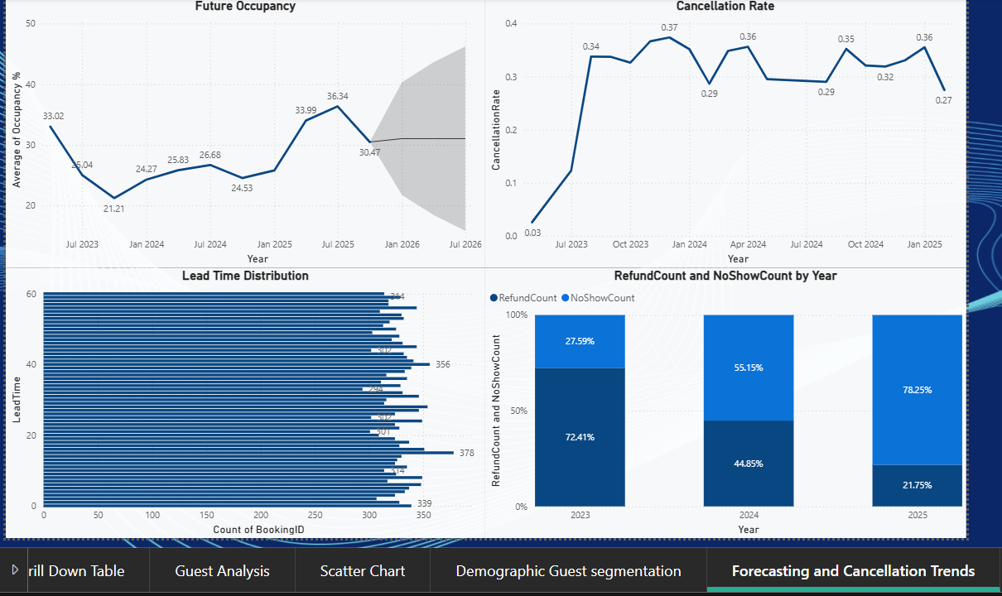

Insights and Learning from Module 4:
  - Clear Cancellation Trends
Cancellation patterns varied by month and year, helping identify periods with high booking instability.

Lead Time Affects Reliability
Bookings made very early or very late showed higher cancellation likelihood, highlighting guest planning behavior.

Forecasting Improved Demand Visibility
Using Power BI’s 7-month forecast with a 95% confidence interval provided reliable insight into future occupancy trends.

No-Show and Refund Patterns Identified
The analysis showed consistent no-show volumes and measurable refund impacts, helping quantify revenue loss.

Better Operational & Revenue Planning
Understanding cancellations, no-shows, and forecasting outputs supports more accurate staffing, pricing, and inventory decisions.

Foundation for Predictive Strategies
The metrics created (LeadTime, CancellationFlag, NoShowFlag, Forecast) prepare the system for advanced cancellation prediction and dynamic pricing models.

Conclusion:
Module 4 provided valuable insights into booking reliability by analyzing cancellations, no- shows, lead time behavior, and refund patterns. Through forecasting techniques and key analytical metrics, the module helped identify periods of high cancellation risk and offered clear visibility into future occupancy trends.
The combined use of DAX calculations, cancellation indicators, and Power BI’s forecasting model supports better operational planning, revenue management, and policy decisions. Overall, this module strengthens the hotel’s ability to anticipate demand, minimize revenue loss, and make data-driven strategic improvements for future business growth.

